**Working with Azure Storage Accounts**

Create the storage account, enable Hierarchical namespace:

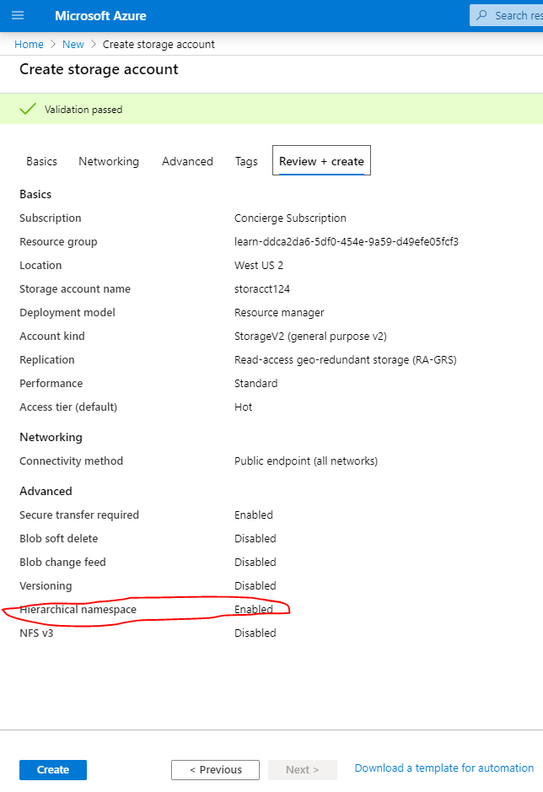

Use the Storage Explorer to copy a sample file into the Blob container that has been created:

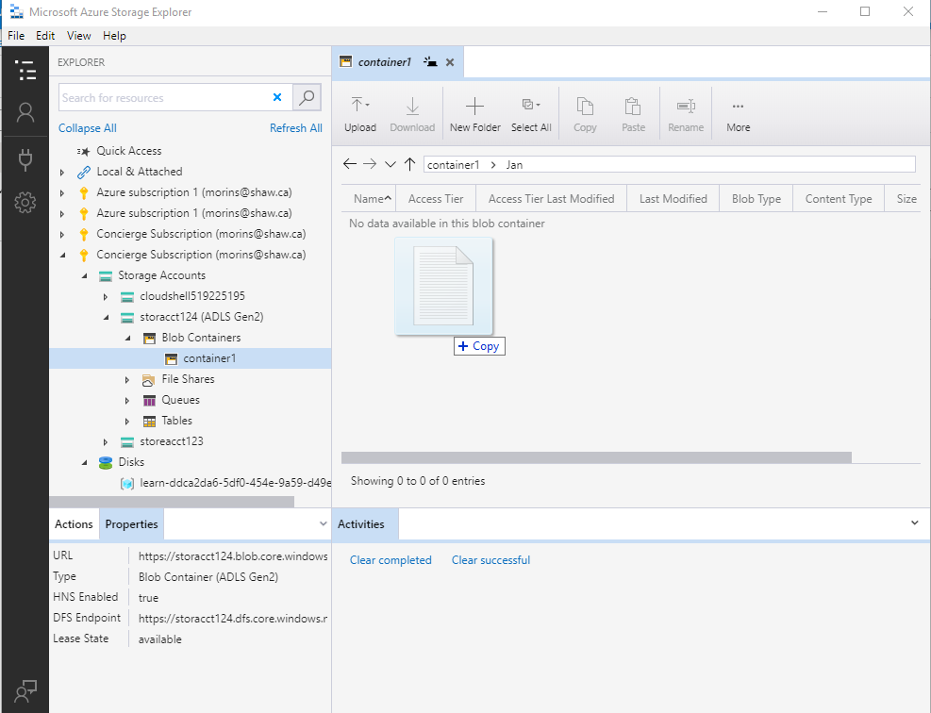

Here is the file shown after being copied:

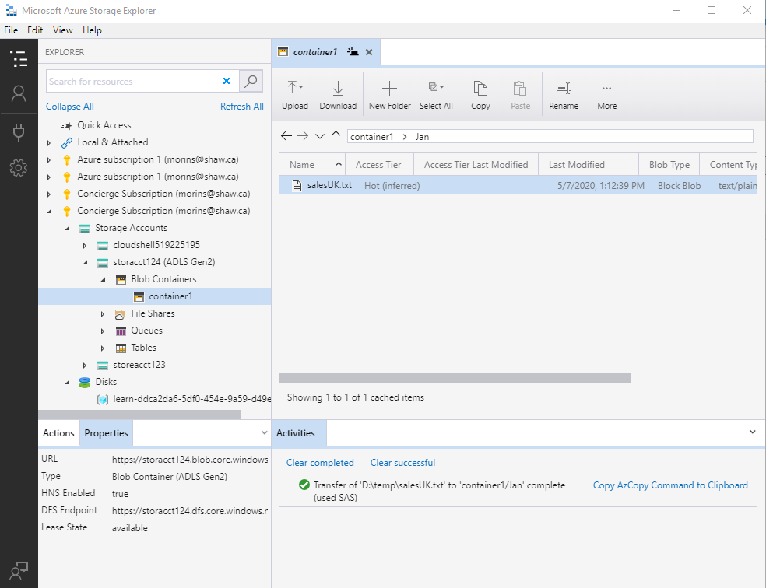

Update the access tier to Hot, Cool, or Archive:

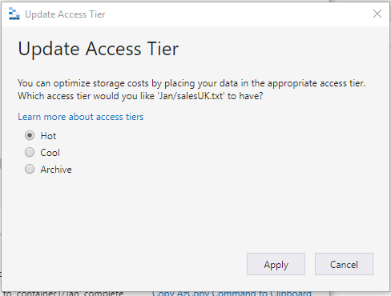

Manage Access to the file:

